# 1: GIT-HOL

**Step 1: Setup Git Configuration**

1. Open Git Bash and check if Git is installed:

Command: git –version

1. Configure Git with your username and email:

Command: git config --global user.name "Srihitha Simhadri" Command: git config --global user.email "[srihithasimhadri@gmail.com](mailto:srihithasimhadri@gmail.com)"

1. Verify the configuration:

Command: git config --list

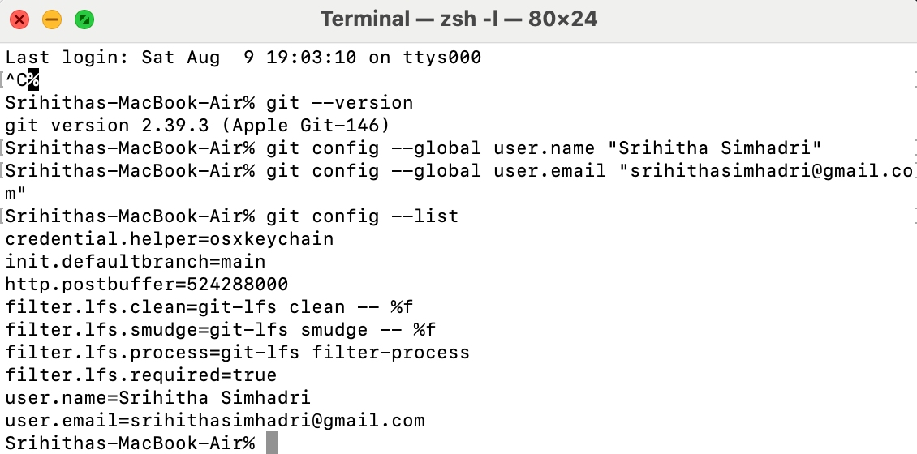

# Step 2: Set Visual Studio Code as Git Default Editor

1. In Git Bash, set Visual Studio Code as the default editor: Command: git config --global core.editor "code --wait"

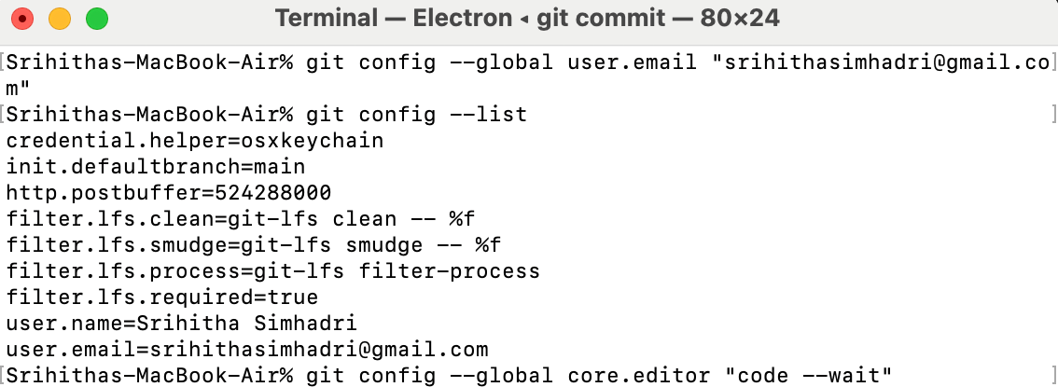

# Step 3: Create Local Git Repository

1. Create a project folder and initialize Git: Command: mkdir ~/Documents/GitDemo Command: cd ~/Documents/GitDemo Command: git init

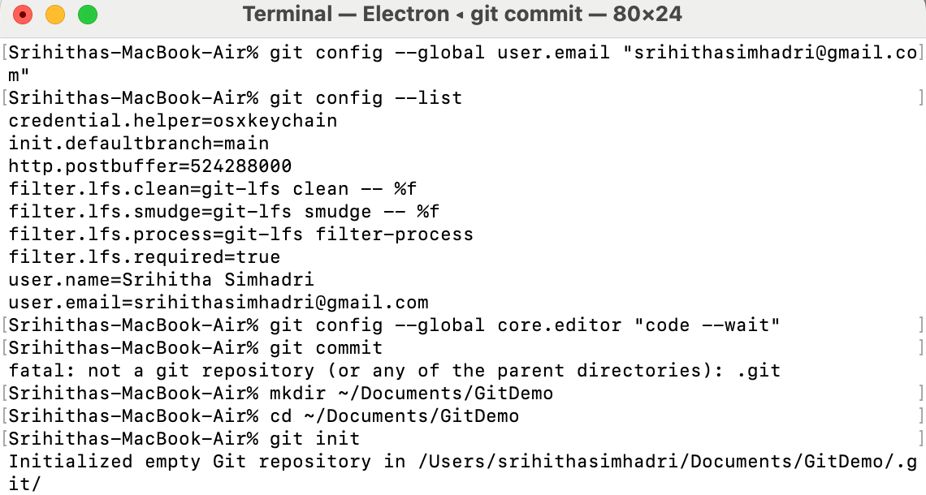

# Step 4: Create and Add a File

1. Create a file named Welcome.txt: Command: echo "Hello Git" > welcome.txt
2. Stage the file:

Command: git add welcome.txt



1. Commit the file:

Command: git commit

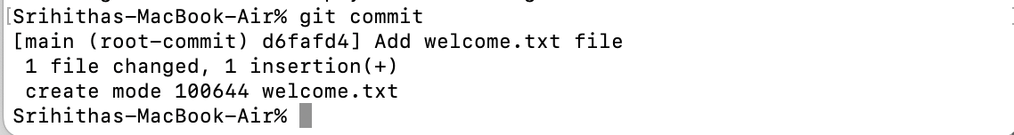

6. Check status again:

Command: git status



# Step 5: Connect to Remote Repository (GitLab)

1. Login to GitLab and create a new project named GitDemo.
2. Link the remote repository:

Command: git remote add origin git@gitlab.com:Srihitha_Simhadri/GitDemo.git

1. Push your local commit: Command: git push -u origin master

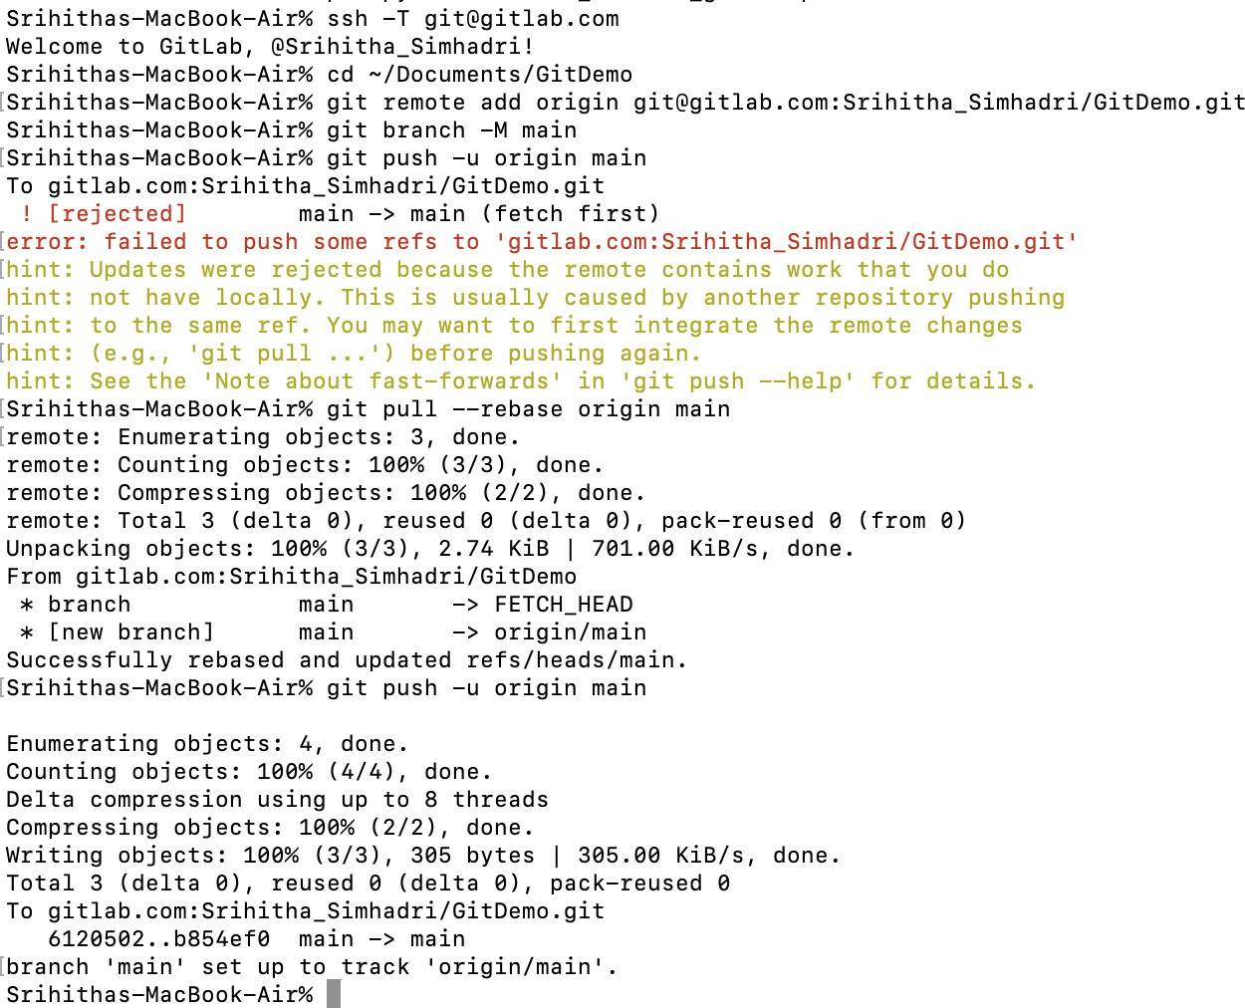

Click on below link to open in gitlab https://gitlab.com/Srihitha_Simhadri/gitdemo.git